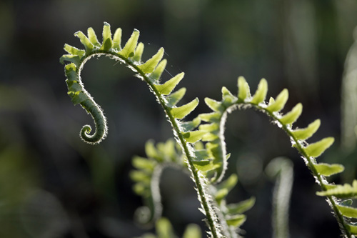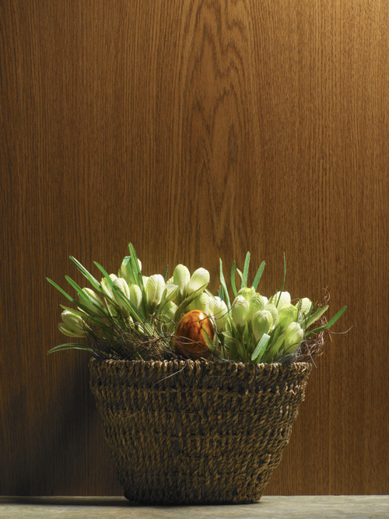 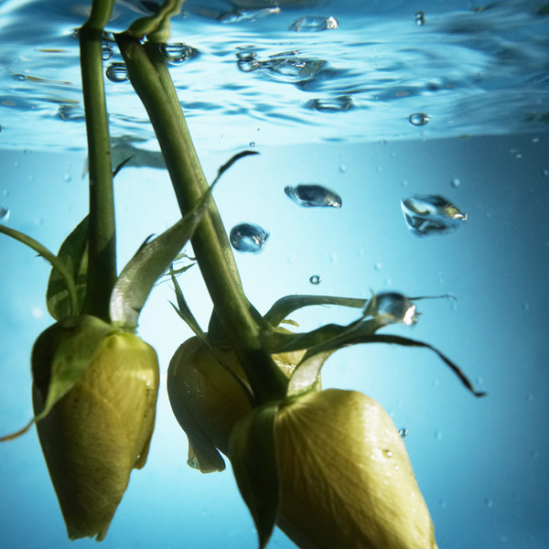

Cover page 1

Name

Mrs. Marroquin

Period

Title (Original Title)

Picture of person/place.

Influential Hispanic/Latino/Latina in the arts (music, art, writing) 3

Research info

on famous person:

Name of famous person and picture, short biography (**bullet points**), include birthdate, where he/she was born, hobbies, spouse, what they are known for, interesting facts about this person, why is he/she important, what do you admire/like about this person?

History of Hispanic 2

Heritage Month (when and how it started).

Table of Contents.

List of References (at least 3 in MLA Format)

3

Use at least 5 pictures that represent various aspects of the culture of your country.

Make sure you have a picture of each of the following:

Pop culture

Folk culture

Housing

And any two other pictures that represent culture in your country.

2

Capital City

At least 3 other neighboring cities

Neighboring countries

Main imports

Main exports

Religion

1

Latin American country where person is from:

Population

Form of government

Crude of birth rate

Crude of death rate

Life expectancy

Natural resources

Purpose: To research and create a brochure that will provide the audience with information about an important person that has contributed to our society and the Hispanic country where the person is from.

Mrs. Marroquin will assign a person to students.

Assignment Due: 10/3 or 10/4- At the start of class. No lates will be accepted.